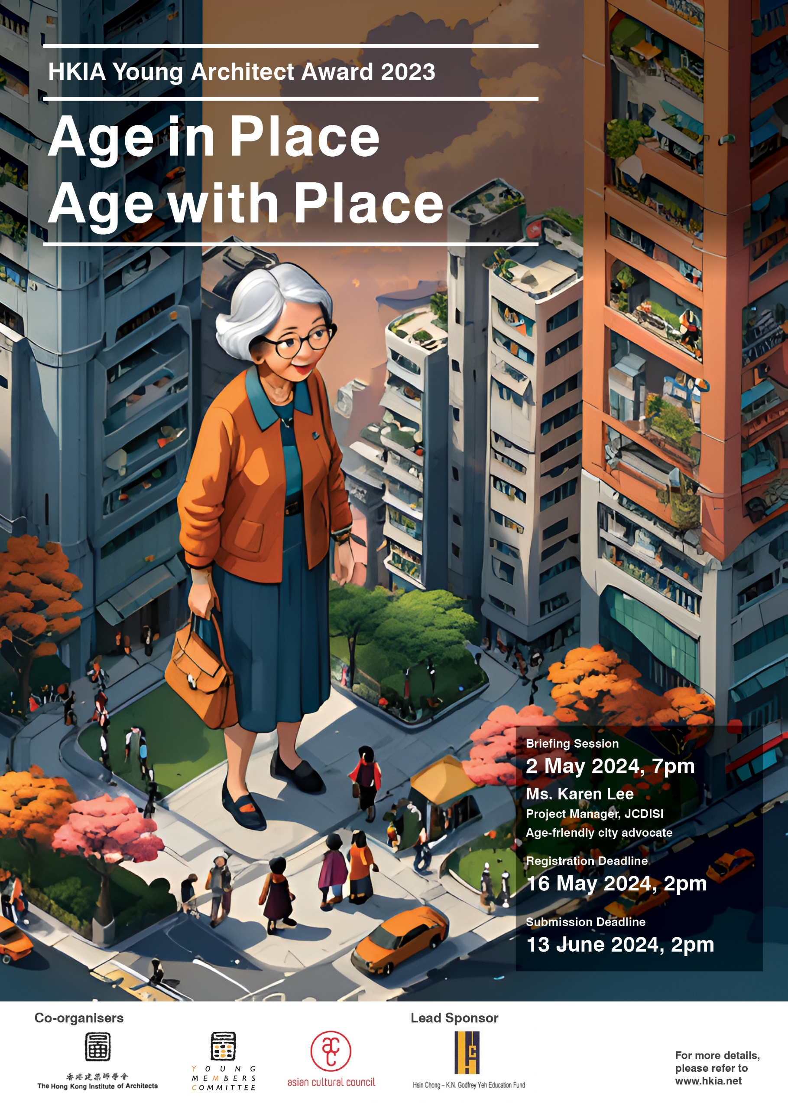
- Young Architect Award (YAA)
1.1 Co-organisers and Lead Sponsor
Co-organisers

The Hong Kong Institute of Architects [HKIA] Asian Cultural Council, Hong Kong [ACC]
http://www.hkia.net http://www.asianculturalcouncil.org
Lead Sponsor

1.2 Objective
To honour and acknowledge the talents and contribution of young architects in Hong Kong

  - Eligibility
- Full Member of HKIA; and
- Aged 35 or below on 31 December 2023 (Date of birth from 1 January 1988)

  - Selection Criteria
The Jury Panel would assess the candidate based on
- Quality of Design Proposal for this Young Architect Award,
- Quality of Previous Personal Work,
- Professional and Social Achievement and Participation, and
- Architectural Study Proposal in the United States or other destination in Asia suggested by the candidate
1.5 Winning Entry
Winner of the HKIA Young Architect Award would be entitled to
- HKIA Young Architect Award Trophy,
- A 3-week Architectural Study Trip to the United States or one destination in Asia suggested in the architectural study proposal. The itinerary shall be proposed by the participant as part of the Submission Criteria; and to be coordinated by the Asian Cultural Council Hong Kong,
- Winning design panel to be displayed at HKIA Premises and HKIA Annual Awards Exhibition, and
- Publication at HKIA Annual Awards Publication, HKIA Journal and other external media.

Besides the winning entry, other appropriate entry may be awarded a subsidy to execute a Career Development Plan proposed by the candidate, including a 12-month mentorship by past YAA recipient and/or senior member. The proposal shall be to be reviewed by the Organising Committee and proposed mentor subsequent to result announcement.

  - Obligation
Winner of the HKIA Young Architect Award would be obligated to
- Join the HKIA Young Members Committee and encourage young members to participate in HKIA affairs,
- Represent the HKIA in participating the professional events organised or recommended by Asian Cultural Council or the Sponsor, and
- Report back to HKIA after his/her Architectural Study Trip or the process of Development Plan actualisation, including but not limited to, mini-documentation, publication, exhibition or social media page.

1.7 HKIA YAA Jury Panel
Juror
Mr. Donald Choi HKIA Fellow, HKIA Past President
Prof. Ling Kar Kan Director, JCDISI; Age-friendly city advocate
Mr. Benjamin Tsang HKIA Young Architect Award 2011 Recipient
Mr. Samuel Wong HKIA Young Architect Award 2020 Recipient
Ms. Alexandra S. Seno Representative of Asian Cultural Council, Hong Kong

Reserve Juror
Mr. Joseph Kwan HKIA Fellow, Universal Accessibility and Age-friendly Community Advocate
HKIA YAA Jury Panel has the final decision on the category and numbers of HKIA Young Architect Award.

1.8 Speaker for Briefing Session
Ms. Karen Lee Project Manager, JCDISI; Age-friendly city advocate

- Design Proposal
2.1 Age in Place, Age with Place
In 2021, the demographic of senior citizens rose to 1 in every 5 of us. Foreseeing aging population in the next few decades, the government would like to achieve “aging in place as the core, institutional care as backup” in the long run. Alleviating the pressure on the public healthcare system and fostering wellbeing of the senior citizens, the concept of “Age in Place” promotes a community of active aging, from accessibility, facilities to communal support. Ultimately, senior citizens living in a familiar neighborhood with adequate communal support would promote wellbeing and a healthier population for the society.

Aging population often compounds with aging urban fabric and physical environment, often know as double-aging, where the deteriorating urban conditions pose additional challenges for senior citizens. Attached to communal bonding of the neighborhood, senior citizens would prefer to stay in the community and “Age in Place” creates a challenge on neighborhood facilities, communal space and accessibility to cope with the ever-changing needs. Kwun Tong, Wong Tai Sin and Sham Shui Po, where both population and urban fabric age over time, see the challenges in tackling this issue in both sociological and architectural scale.

Therein lays the opportunity for fellow young architects in designing for an age-friendly cities. The award invites proposals to rejuvenate the aging community at an appropriate scale to promote “Aging in Place” while preserving neighborhood bonding that supports the senior citizens and their wellbeing.

2.2 Programme
Participant can propose any programme(s), primarily communal and cultural related, to demonstrate his/her design vision.

2.3 Schedule of Accommodation
Participant proposes a schedule of accommodation to suit his/her proposal.

2.4 Location
Participant can propose any location(s) in the urban context to demonstrate his/her design vision.

2.5 Reference
- World Health Organization (WHO) guidelines on age-friendly cities
https://www.who.int/publications/i/item/9789241547307

- Aging Population and Elderly Services in Hong Kong
https://storymaps.arcgis.com/stories/e22194245c6f4d6b8f25ce7ac101dc48#:~:text=The%20districts%20with%20the%20highest,HK%20East%20and%20Wan%20Chai
- Research, Jockey Club Design Institute for Social Innovation (JCDISI)
https://www.polyu.edu.hk/disi/research/

- Happy Aging Lab
https://www.happyageinglab.com

- Submission Requirement
3.1 Registration
Registration is required for submission to Young Architect Award 2023 to confirm his / her eligibility. Registration should be made through the online registration form by the stipulated deadline listed under Clause 3.5 Award Schedule. Email confirmation would be sent to eligible participant shortly after the close of registration.
Those who have not registered will not be accepted to enter the award competition.

3.2 Enquires
All enquiries shall be made to HKIA secretariat (Attn. Ms. Annok Kong) through the communication channel listed below.
Email : bia@hkia.org.hk
Tel : 2511 6323

3.3 Document Submission
Submission package shall be consisted of the followings, with candidate’s name marked at the back of the materials:
(i) Completed and signed Entry Form in A4-size
(ii) 4 nos.of A2-size Design Proposal Panel, mounted on foamboard
(iii) Design statement in A4-size (not more than 500 words in English)
(iv) DVD-ROM / USB with softcopy of Item (i) (in DOC and PDF format), Item (ii) (individual panels in PDF format, together with a JPG image showing the composite appearance of the panels with horizontal dimension not less than 3,000 pixel) and Item (iii) (in DOC and PDF format)
Materials and USB submitted for the award would not be returned to the candidate. All other submission not listed above would not be permitted.

3.4 Submission Format
Submission package shall be submitted to the HKIA Secretariat during office hour by post or by hand and it must be received by the stipulated time under Clause 3.5 Schedule.

3.5 Award Schedule
Item | Key Date | Remarks
Commencement of  YAA Design Proposal | 18 April 2024  (Thursday) | HKIA website
Briefing Session | 2 May 2024  (Thursday) | At HKIA Premises  Briefing Session:  https://forms.gle/2MU7Xf62vQX5NN9Z9
Registration Deadline | 16 May 2024  (Thursday)  2:00pm | Registration is required for submission to Young Architect Award 2023.  Registration: https://forms.gle/HDNxa7aDtLmVzNL36
Submission Deadline | 13 June 2024  (Thursday)  2:00pm | Your submission package shall be submitted to HKIA Secretariat
Jury Shortlisting Process | 15 – 28 June 2024
Interview of Shortlisted  Candidates | 29 June 2024  (Saturday) | Shortlisted Candidates must attend this Interview Session
Announcement of Result | July 2024 | HKIA website

HKIA YOUNG ARCHITECT AWARD (YAA) 2023
ENTRY FORM

Section 1 - Candidate’s Particulars [Page 1 of 2]
Name |  |  | (Chinese)
 |  |  | (English)
HKIA Full Membership No.
Email
Telephone No.
Date of Birth
Education |  | Year
Professional Qualification |  | Year

Note
1. All experience in Section 1 - Participant’s Particular shall be listed in reversed chronological order, starting from the most recent experience.
2. Please append extra sheets if additional space is required for all the above information
3. The shortlisted candidate will be required to present the above record for reference.
Section 1 - Candidate’s Particulars [Page 2 of 2]
Working Experience | Year
Previous Awards, Prizes, Scholarships | Year
Publications / Paper written and/or given | Year
Participation in services to the Profession and the Community | Year
Section 2 - Proposed Study Tour
[Page 1 of 2]
Candidate must agree to spend 3 continuous weeks in the United States or one destination in Asia suggested by candidate on a professional visit. Please state itinerary proposal with objective and visit details including but not limited to organization / person / architecture / programme / relevant information.
Section 2 - Proposed Study Tour
[Page 2 of 2]

Section 3 - Summary of Presentation Documentation &
Portfolio of Previous Personal Work

Shortlisted candidate will be required to attend interview session with supporting documentation to demonstrate his / her idea and achievement as follows:
Quality of Design Proposal for this YAA
(e.g. Research & reference document)
1.
2.
3.
4.
Quality of Previous Personal Work
(e.g. Portfolio with the project names to be stated herein)
1.
2.
3.
4.
Professional and Social Achievement and Participation
(e.g. Portfolio with the project names to be stated herein)
1.
2.
3.
4.
Architectural Study Proposal in the United States or Asia
(e.g. Research & reference document)
1.
2.
3.
4.
Section 4 - Professional Reference

Personal particulars of 2 nos.of Referees proposed by the candidate. The Jury may contact the captioned Referees of the shortlisted candidate for further assessment and reference.

 | 1st Referee
 | Name |  | (Chinese)
 |  |  | (English)
 | E-mail
 | Mailing Address
 | Tel.
 | 2nd Referee
 | Name |  | (Chinese)
 |  |  | (English)
 | E-mail
 | Mailing Address
 | Tel.

Section 5 - Declaration

I declare that all information stated on this Entry Form together with any subsequent information provided to the Organising Committee are correct, true and complete.

Candidate’s Name
Candidate’s Signature
Date

